B Municipality of Calintaan, Province of Occidental Mindoro

- General Information
Title:Ten (10) Year Ecological Solid Waste Management Plan (2019 – 2028)
Municipality of Calintaan, Province of Occidental Mindoro |  | Classification: Third Class
Total Population:  31, 222 (2019)  34,606 (2028) |  | Number of Barangays: 7  Urban – 1  Rural - 6
SWM Information
Indicator | Baseline |  | 10-Year Plan
% of segregation at source | 50.00% |  | 100%
% of segregated collection | 50.00% |  | 100%
% of collection rate/service area | 50.00% |  | 100%
% waste diversion rate | 56.00% |  | 84.86%
With disposal facility (cap =m/yr or tpy) | 4,328.74 |  | 1,650.47kgs/day

- Strategies to achieve the 10-year plan targets with budgetary allocation per year for:
- Establishment of Sanitary Landfill Category 1
- Procurement of SWM equipment, facilities, and machineries
- Positioning of Manpower Services
- Strengthening/Intensification on waste segregation, reduction, diversion, and composting at source
- Strict implementation of RA 9003 Prohibitions
- SWM PPAs
- Extended service areas for segregated collection
- Operation and maintenance of SLF, SWM equipment, facilities, and machineries

SWM Functional Element | Strategies
- Establishment of Sanitary Landfill Category 1 | - Regular Operation and Maintenance of SLF  - Employment of Care takers
B. Procurement of SWM Equipment, Facilities, and Machineries | - Equipment:  - Municipal garbage truck/s for Barangay residual and special waste collection  - Barangay Garbage trucks for Barangay compostable and residual wastes collection;  - Top-down tricycles for Barangay recyclable and special wastes collection.  - Facilities:  - Establishment of MENRO Office;  - Temporary Residual Containment Area (TRCA)  - Production/Processing Area  - Additional vault for Special Wastes,  - Barangay and School MRFs  - Recyclable Depots at the conspicuous places in the town and at the Barangay;  - Pick – up Point Areas;  - Composting areas.  - Machineries:  - All Kinds of Necessary Shredding Machines;  - Baling Machines; and  - Extruding Machines.
C. Positioning of Manpower services | - Presence of MENRO Office with plantilla/permanent positions for MENRO and Staff  - Employment of SWM manpower services detailed at:  - MENRO Office,  - SLF/Central MRF/TRCA/Central Composting Facility,  - Production/Processing Area, and  - Municipal and Barangay MRFs.
D. Strengthening/  Intensification on Waste Segregation, Reduction, Composting, and Diversion at Source | 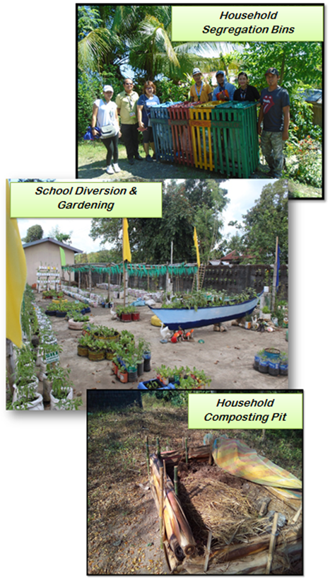  - Strengthening of functional MSWMB & BSWMC & Purok/Sitio leaders on SWM plans and programs  - Massive and intensive environmental Information, Education and Communication campaigns (Barangay Assembly, Fora, Trainings, Symposia, House to House campaigns)  - Mandatory to all households, offices, schools, stores, shops:  - Waste Segregation at Source  - Provision of 4 types of segregation bins with sacks and label  - “No segregation, no collection” policy  - Waste Reduction at Source  - No To Non-Recyclable Plastic Policy  - Single Packaging System  - BaHa (Basket Habit)  - BOBES (Bring Own Basket Every Shopping)  - Waste Composting at Source  - Presence of composting pit/s or bins at the household’s compound  - Waste Diversion at Source  - Presence of crafts at home, offices, stores, etc.  - Diverted pots for flowering plants and backyard gardening  - Establishment of linkages between and among LGU Offices with related functions: MAO, MEO, etc.
E. Strict implementation of RA 9003 Prohibitions | - Mandatory monitoring of BSWMC/BSWMP/SL for :  - Waste Burning,  - Illegal disposals on all areas: closed disposal facility, rivers, canal, coastlines, vacant lots, etc.  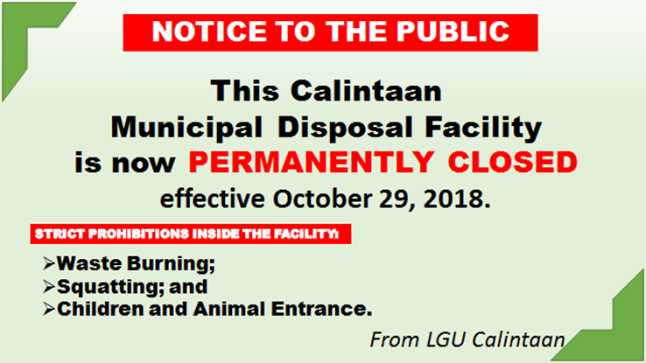  - Littering on: thoroughfares, streets, store vicinity, Municipal & Barangay compound, markets, etc.  - Squatting and entrance of children at the Closed Disposal Facility  - Use of disposable plastics on all occasions.
F. SWM PPAs | - Implementation of Project CALINTAAN (CALl for INTerdependent Action against wAste Nonchalance) and Project ECL (Empowering Community Leadership) e.g BaHa, BOBES  - Execution of Municipal and Barangay Ordinances  - Provision of segregation bins for Barangays  - Conduct of municipal-wide competition for SWM e.g. Search for Cleanest Barangay, Best School SWM Implementers, etc.  - Establishment and operation of School MRFs and Gardening  - Barangay Acquisition of shredding machines for compostable to seven barangays and multi-shredding and baling machine for residuals  - Establishment, operation and maintenance of Central and Barangay MRFs  - Establishment of marketing opportunities for waste by-products, organic fertilizers and recyclable products.  - Organization of the SWM Monitoring and Evaluation Committee  - Maintenance and beautification of Municipal Eco-Park/closed disposal site  - Segregation bins for all PUVs  - Creation of MENRO Hotline for reporting
G. Extended service areas for segregated collection | - All puroks and sitios in every barangay shall have a schedule for segregated waste collection date and time;  - Provision of pick-up point areas in crowded areas and sitios
H. Operation and maintenance of SLF, SWM equipment, facilities, machineries | - For the 10 year planning period a total of: (details are given in annexes that follow:  Particulars TOTAL  Investment Cost 41,338,000  Annual Cost (PS & MOOE) 15,133,914  Total 56,471,914

- Planned Waste Management System

Item and Description | Ten-Year Planning Plan
 | 2018 | 2019 | 2020 | 2021 | 2022 | 2023 | 2024 | 2025 | 2026 | 2027 | 2028 | Total
I. Collection & Transport
*Establishment of pick-Up point areas |  |  | 250,000 | 250,000 |  |  |  |  |  |  |  | 500,000
II.MATERIAL RECOVERY FACILITY
*Improvement of Central MRF |  |  |  |  | 1,000,000 |  |  |  |  |  |  | 1,000,000
*Procurement of Necessary Materials (Scales, spade, rake, etc) |  | 5,000 |  |  |  |  |  | 5,000 |  |  |  | 10,000
III. DISPOSAL MANAGEMENT
*Establishment of TRCA | 1,000,000 |  |  |  |  |  |  |  |  |  |  | 1,000,000
*Production/Processing Area w/ Office & CR |  | 2,000,000 |  |  |  |  |  |  |  |  |  | 2,000,000
*Establishment of Additional Vault |  |  | 250,000 |  |  |  |  |  |  |  |  | 250,000
Maintenance/operation Expenses |  | 100,000 | 100,000 | 100,000 | 100,000 | 100,000 | 100,000 | 100,000 | 100,000 | 100,000 | 100,000 | 1,000,000
*Establishment of SLF |  |  |  | 15,000,000 |  |  |  |  |  |  |  | 15,000,000
*Procurement of Garbage Trucks |  | 5,500,000 |  |  |  |  | 5,700,000 |  |  |  |  | 11,200,000
*Procurement of Top-Down Tricycles for Barangays |  |  | 700,000 |  |  |  |  |  |  |  |  | 700,000
*Procurement of Multi-Shredding & Baling Machines |  | 2,000,000 | 2,000,000 |  |  | 2,000,000 |  |  |  | 2,000,000 |  | 8,000,000
*Procurement of Extruders (bricks, hollow block, balusters, paving blocks |  | 500,000 |  |  |  |  |  |  |  |  |  | 500,000
Total | 1,000,000 | 10,105,000 | 3,300,000 | 15,350,000 | 1,100,000 | 2,100,000 | 5,800,000 | 105,000 | 100,000 | 2,100,000 | 100,000 | 41,150,000
Table 35. INVESTMENT COST UNDER 20% DEVELOPMENT FUND, 2019 - 2028
Annex A

Annex B
Table.36: Annual Cost under Maintenance and Other Operating Expenses, 2019 – 2028
Item & Description | Ten-Year Planning Program
 | 2019 | 2020 | 2021 | 2022 | 2023 | 2024 | 2025 | 2026 | 2027 | 2028 | Total
*Fuel/Lubricants | 150,000 | 150,000 | 150,000 | 155,000 | 155,000 | 160,000 | 160,000 | 160,000 | 160,000 | 160,000 | 1,560,000
*Vehicle maintenance ,repair, and spare parts | 150,000 | 150,000 | 150,000 | 150,000 | 150,000 | 150,000 | 150,000 | 150,000 | 150,000 | 150,000 | 1,500,000
*Protective gears & supplies | 8,000 | 8,000 | 8,000 | 8,000 | 8,000 | 8,000 | 8,000 | 8,000 | 8,000 | 8,000 | 80,000
*General Services | 264,000 | 264,000 | 264,000 | 330,000 | 330,000 | 330,000 | 330,000 | 330,000 | 330,000 | 330,000 | 3,102,000
*Utilities (Elec. Expenses) | 3,000 | 3,000 | 3,000 | 3,000 | 3,500 | 3,500 | 3,500 | 3,500 | 3,500 | 3,500 | 33,000
*Office supplies | 70,000 | 70,000 | 70,000 | 70,000 | 70,000 | 70,000 | 70,000 | 70,000 | 70,000 | 70,000 | 700,000
*Traveling Expenses | 100,000 | 100,000 | 100,000 | 100,000 | 150,000 | 150,000 | 150,000 | 150,000 | 150,000 | 150,000 | 1,300,000
*Training Expenses | 50,000 | 50,000 | 50,000 | 50,000 | 50,000 | 50,000 | 50,000 | 50,000 | 50,000 | 50,000 | 500,000
*IEC Materials | 8,000 | 8,000 | 8,000 | 8,000 | 8,000 | 8,000 | 8,000 | 8,000 | 8,000 | 8,000 | 80,000
SWM Programs/Projects | 500,000 | 500,000 | 500,000 | 500,000 | 500,000 | 500,000 | 500,000 | 500,000 | 500,000 | 500,000 | 5,000,000
Total | 1,303,000 | 1,303,000 | 1,303,000 | 1,374,000 | 1,424,500 | 1,429,500 | 1,429,500 | 1,429,500 | 1,429,500 | 1,429,500 | 13,855,00

Source: MENRO 2018

Table 37: Personnel Services, 2019 - 2028
Annex C
Item & Description | Ten-Year Planning Period |  |  |  |  |  |  |  |  |  | TOTAL
 | 2019 | 2020 | 2021 | 2022 | 2023 | 2024 | 2025 | 2026 | 2027 | 2028
I. Collection & Transport
Plantilla positions for:
*Drivers | - | - | - | - | 72,550 | 72,550 | 72,550 | 72,550 | 72,550 | 72,550 | 435,300
*Collectors |  |  |  |  |  |  |  |  | 9,184 | 9,184 | 18,368
II. Program Implementation
Plantilla positions for:
*MENRO | 65,075 | 65,075 | 65,075 | 65,075 | 65,075 | 65,075 | 65,075 | 65,075 | 65,075 | 65,075 | 650,750
*Admin. Aides |  |  |  | 9,184 | 9,184 | 18,368 | 18,368 | 18,368 | 27,552 | 27,552 | 128,576
*Utility |  |  |  |  |  | 9,184 | 9,184 | 9,184 | 9,184 | 9,184 | 45,920
Total | 65,075 | 65,075 | 65,075 | 74,259 | 146,809 | 165,177 | 165,177 | 165,177 | 183,545 | 183,545 | 1,278,914
Source: MENRO 2018

Annex D
Table 38: Capital Outlay, LGU Calintaan 2019 - 2028
Item & Description | Ten-Year Planning Period |  |  |  |  |  |  |  |  |  | Total
 | 2019 | 2020 | 2021 | 2022 | 2023 | 2024 | 2025 | 2026 | 2027 | 2028
I. Program Management
* Additional Laptop | 70,000 | - | - | - | - | 70,000 | - | - | - | - | 140,000
*Camera | 30,000 | - | - | - | - | - | - | - | - | - | 30,000
*Speaker with Microphone | 8,000 | - | - | - | - | - | - | - | - | - | 8,000
Total | 108,000 | - | - | - | - | 70,000 | - | - | - | - | 178,000
Source: MENRO 2018

